IMPORTANT

Backing up the Database

Backup Utility

You’ll find our backup utility in the SQL Anywhere Server 17 Program Files folder in the Start menu on the server. Click on the Database Backup and it will run the backup for you during the day while others are still on the system. However it will override the backup from the night before so if you are looking for the one that is from the prior day DO NOT do this. First go to the old backup folder and rename that one.
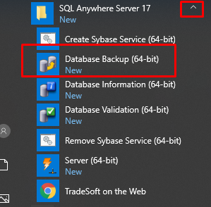
If you’ve kept the default location, the backup utility copies a mirror image of the shared database to:
C:\PPAKSRVR17\BACKUP\ENGINE.DB.

