- On Server Computer, shutdown database by right-clicking SQL icon in the lower right taskbar, and selecting Exit. If you are running the server as a service, please refer to our Note at the bottom of the document.



- Open Windows Explorer by going to Start Menu | All Programs | Accessories or double-click the My Computer icon on your desktop
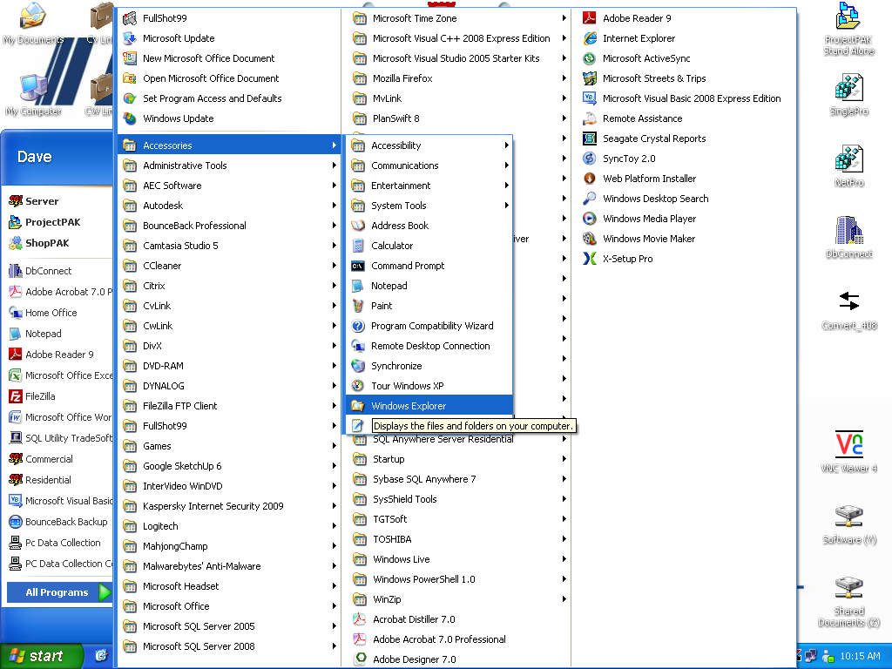

- Locate the folder your database software has been installed inside…default location is C:\PpakSrvr11.

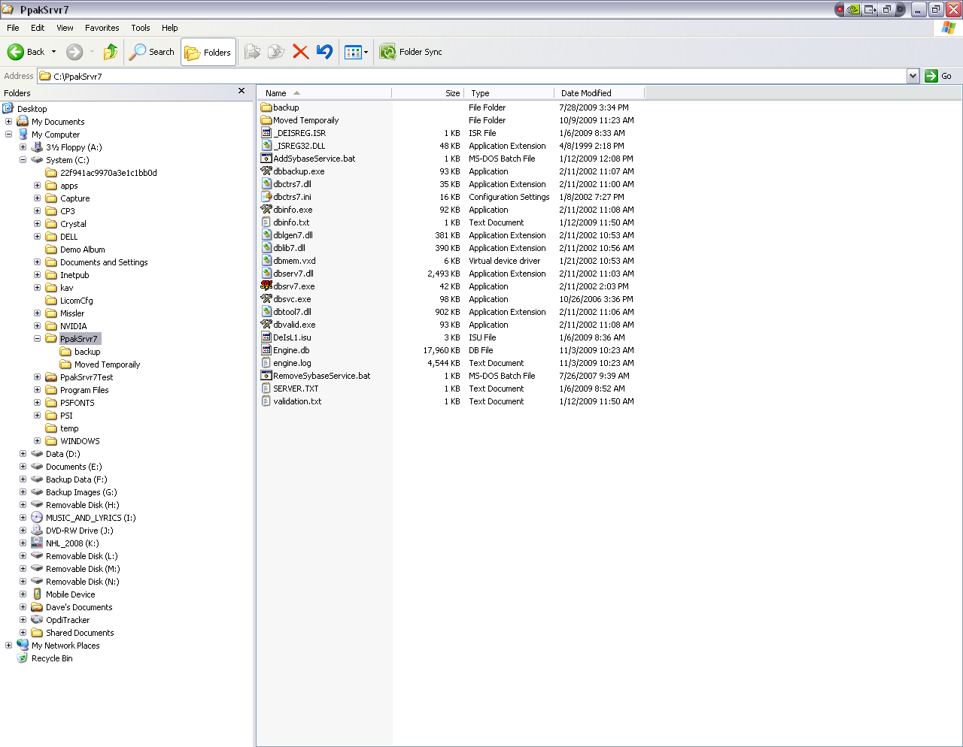
- Select the file labeled ‘Engine.db’, and then right-click and select Send To | Compressed Folder or optionally use your favorite third party zip utility
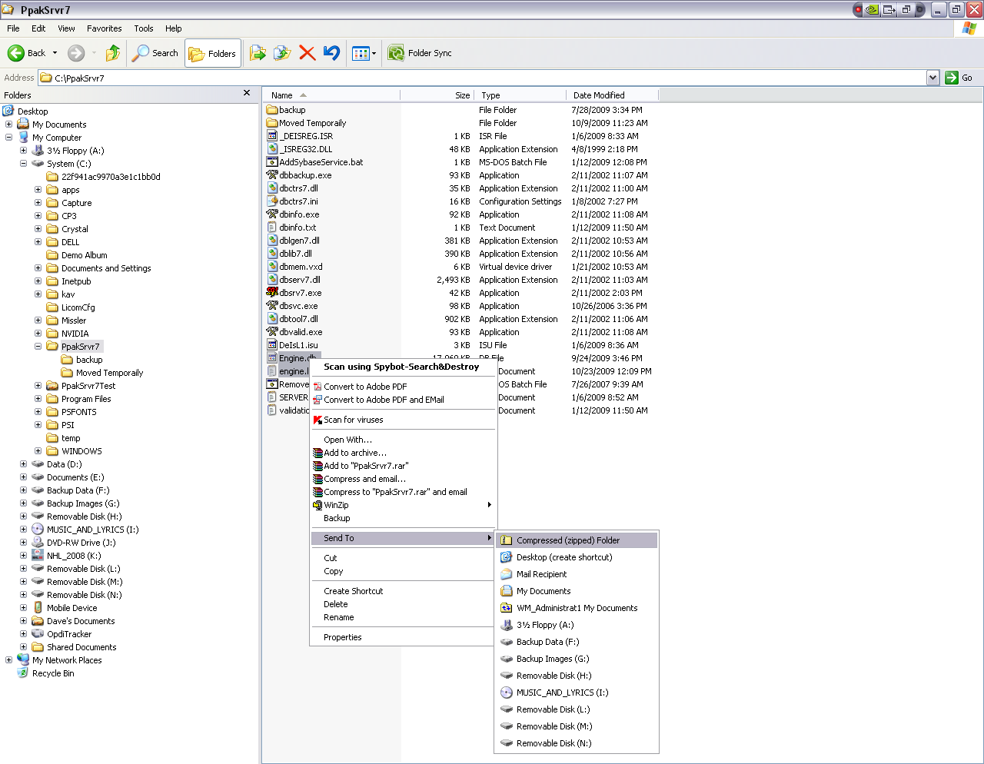
- Right-click the newly created file and select Rename. Label it with your company name and today’s date and hit enter
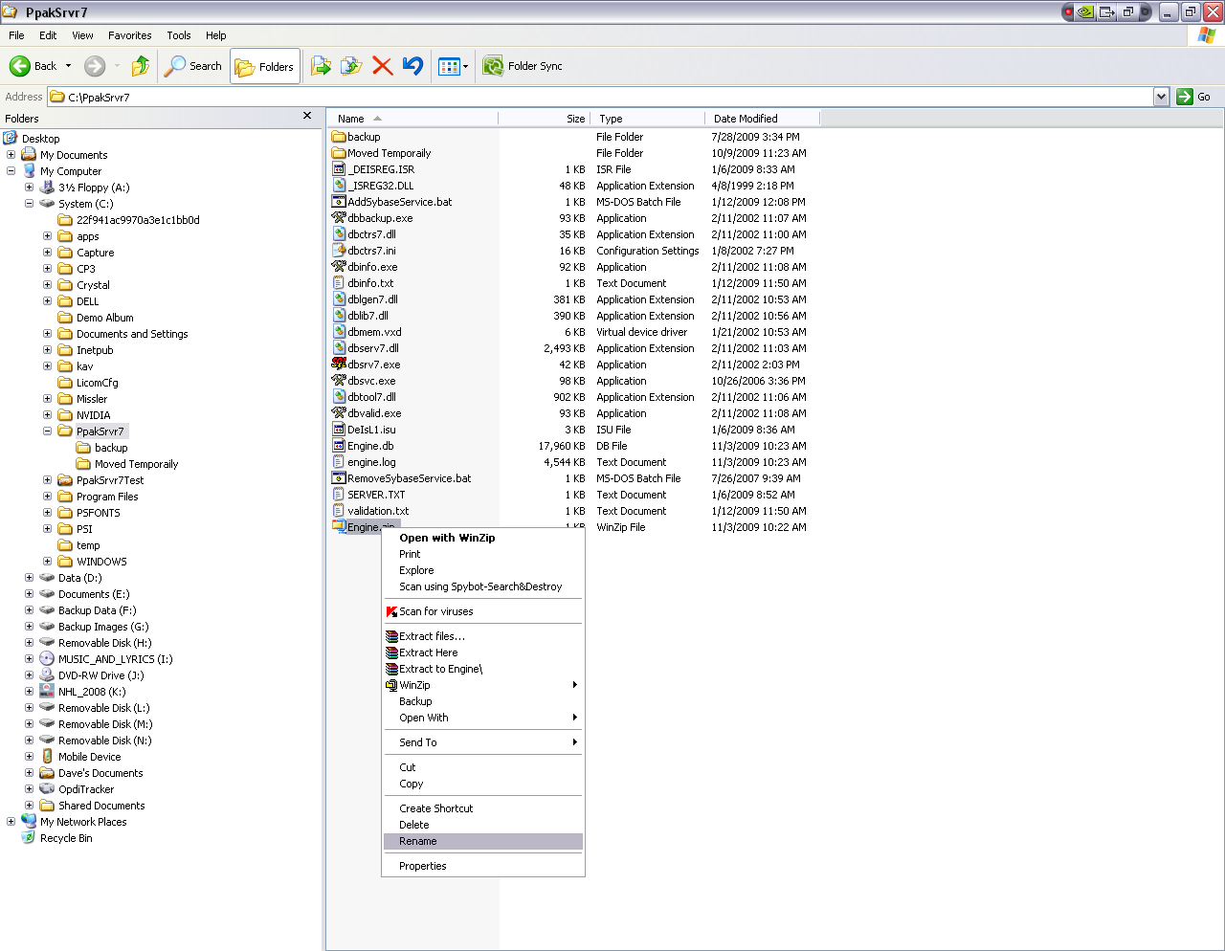

- You can now restart your database by going to Start | All Programs | SQL Anywhere Server 11 and clicking the Server shortcut. You can also your desktop shortcut if you have one.

- Follow the FTP instructions below to upload this zipped file to our FTP site

Note: If you are running the database as a service, then you’ll need to actually stop the service in order to zip up the files. Go to Start | Control Panel | Administrative Tools | Services and look for the service called “SQL Anywhere-TradeSoft11'. Click the Stop link on the left hand side or right-click and choose Stop. Once you have zipped up the files, you can go back to the Services window and click the Start link or right-click and choose Stop.

FTP Upload Instructions.

Note: If you have uploaded a file with us in the recent past, then chances are you already have Filezilla installed and so you can skip this first step.
First, go to the website below and download the FileZilla Client. You should see two links at the bottom of the page, one for client and the other for server. We are using this software for our FTP. I have downloaded and set up the server on our side. All you will have to do is install this client onto your computer and apply the correct log in information.

http://filezilla-project.org/
Next, you will need to run the setup. Once this is done, let's start up FileZilla. You should come to a screen like the one below.

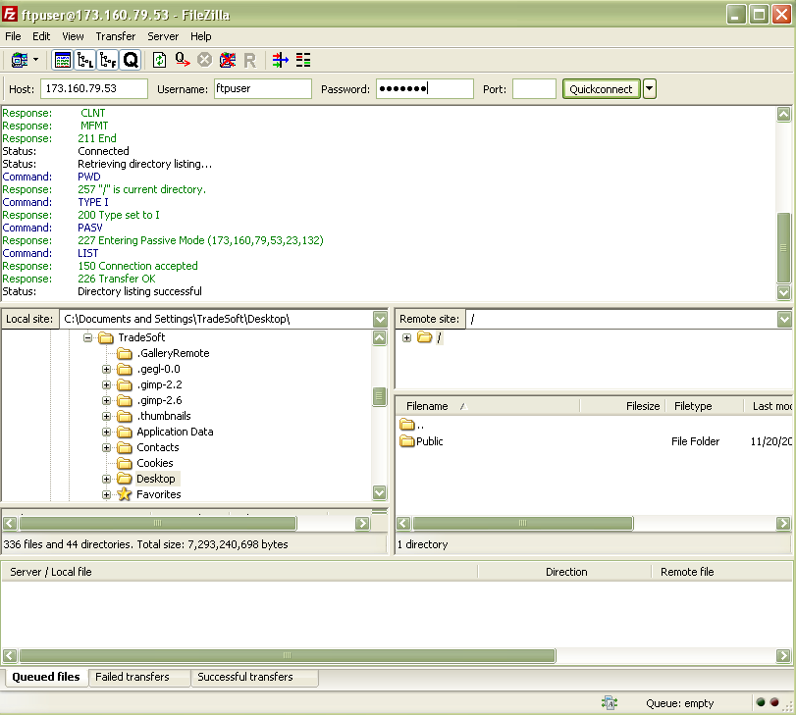
Now all you will need to do is enter our ip address into the host field (96.71.75.89), the username (ftpuser), and the password (ftpuser). The username/password is just like before, but now you don't have to include @tradesoftinc.com with the username. Once this is done, click the Quickconnect button. Another thing that is nice about this program is that once you have entered this information the first time, you won't have to do it again. Next time just click on the down arrow next to the Quickconnect button and choose the ftpuser connection.

You should see a folder in the bottom right window. It says Public. This will be the folder you use to download files into or upload files from the FTP server.

The left hand side dictates your side of the ftp. This is where you will point to which area on your computer you will want to download a file to. As you can see on my screen, I am pointing to the desktop, so anything I double-click on inside the Public FTP folder will download to my desktop. This also works for uploading. If you want to upload a file into the Public folder, just find it by using the left hand side. As you can tell, it has a very explorer-type interface on this side.

Note: If preferred, can also drag files into the Public folder from your desktop or any actively opened folder on your computer screen.

The very bottom window displays the download/upload activity. Whenever you are performing one of these, you will see a status bar in this window telling you what percentage is done, how much longer, and at what speed it is being done at. A very nice feature compared to the old Windows estimated time way of things!

